Cognizant Technology Solution

Internship report
Submitted in Partial Fulfillment of the
Requirement for Award of the Degree
of

BACHELOR OF TECHNOLOGY
In
MECHANICAL ENGINEERING

By
Amit Patel

(11509056)

Under the Guidance of

Mr. Mohit Kariya (industry supervisor) and Mr. Sugandh gupta (University Mentor)


DEPARTMENT OF MECHANICAL ENGINEERING
LOVELY PROFESSIONAL UNIVERSITY
PHAGWARA, PUNJAB (INDIA) -144402
2018-19


Lovely Professional University Jalandhar, Punjab

CERTIFICATE

I hereby certify that the work which is being presented in the internship entitled “Cognizant Technology Solution” in partial fulfillment of the requirement for the award of degree of Bachelor of Technology and submitted in Department of Mechanical Engineering, Lovely Professional University, Punjab is an authentic record of my own work carried out during period of internship under the supervision of Mohit Kariya, Supervisor, Department of Mechanical Engineering, Lovely Professional University, Punjab.

The matter presented in this internship has not been submitted by me anywhere for the award of any other degree or to any other institute.

Date: ( Amit Patel )

This is to certify that the above statement made by the candidate is correct to best of my knowledge.

Date: ( Mohit Kariya )

Supervisor

The B- Tech Internship examination of ABC, has been held on _____________

Signature of Examiner

ACKNOWLEDGEMENT

The internship opportunity I had with Cognizant Technology Solutions Pvt. Ltd. was a great chance for learning and professional development. Therefore, I consider myself as a very lucky individual as I was provided with an opportunity to be a part of it. I am also grateful for having a chance to meet so many wonderful people and professionals who led me through this internship period.
Bearing in mind previous I am using this opportunity to express my deepest gratitude and special thanks to the CEO of Cognizant Technology Solutions Pvt. Ltd. who in spite of being extraordinarily busy with his duties, took time out to hear, guide and keep me on the correct path and allowing me to carry out my project at their esteemed organization and extending during the training.
I express my deepest thanks to Mr. Mohit Kariya as Supervisor/batch owner for taking part in useful decision & giving necessary advices and guidance and arranged all facilities to make internship easier and successful. I choose this moment to acknowledge his contribution gratefully. It is my radiant sentiment to place on record my best regards, deepest sense of gratitude to Mrs. Manisha Shah, section Mentor, for her careful and precious guidance which were extremely valuable for my study both theoretically and practically. I perceive as this opportunity as a big milestone in my career development. I will strive to use gained skills and knowledge in the best possible way, and I will continue to work on their improvement, in order to attain desired career objectives. Hope to continue cooperation with all of you in the future.

Sincerely,
Name: Amit Patel
Place: Pune, Hinjewadi
Date:

Declaration

I hereby declare that I have completed four months of my training at Cognizant Technology Solutions Pvt. Ltd, Hinjewadi, Pune from January 2018 to April 2018 under the guidance of Mrs. Manisha Shah. I have declared that I have worked with full dedication during these four months of training and my learning outcomes fulfill the requirements of training for the award of degree of Bachelor of Technology in Mechanical Engineering, Lovely Professional University, Phagwara.

Amit Patel
Date: 30 April 2019 Regd. No:11509056

TABLE OF CONTENTS PAGE NO.
- Company Profile
- Business Profile
- Session1: Design Thinking
- Five stage of design thinking
- Session 2: Agile SDLC
- Agile Manifesto principle
- Agile vs. Traditional SDLC model
- Session 3: DevOps
- DevOps Working
- DevOps importance and practices
- Project Undertaken: Student Teacher Connect (Web based application)

- Conclusion
- Reference

1. COMPANY PROFILE

The company is split into two new major services, Nelson Media Research, and IMS Health. After some time, it became the public subsidiary of the IMS Health. But in 2003, Cognizant sold all its shares in the subsidiary and the CEO also resigned from his post. The company expanded its work from IT services to Outsourcing and business consulting as well. There was a fast growth in the success of Cognizant. The services provided include application development, business intelligence, supply chain management, CRM, etc
Cognizant also follows a global model for delivery. There are many offshore offices of the companies span over many countries in the world. The main sources of business for the company were the American as well as European clients. The company is a provider of high-end services in all fields. It is one of the top 10 companies that are legitimate in bringing the employee on H-1B into the US.
The company also has plans to increase its US business operations in the coming years. A total of 50 recruiters is continually hiring in the United States for different positions in the US itself. The company has nine delivery centres in the United States, Bridgewater, New Jersey; Phoenix, Arizona, Des Moines Iowa, etc.
Cognizant houses around 150,000 employees and has spanned all over the world. There are many development centres of the company as well. There are many units which are divided into vertical and horizontal sections. The vertical unit is for Healthcare, Retail, Banking Services, whereas the horizontal unit focuses on mobile computing, testing, and BPO. More than 100,000 employees work in India. The major revenue of the company is from financial companies and then from healthcare industries.
The company also launched the Go Green initiative in the year 2008. This cause completely focused on recycling, waste management, and energy conservation.
Cognizant is the 50th traded companies in the United States.

Business Model:

Like many other IT services firms, Cognizant follows a global delivery model based on offshore software R&D offshore outsourcing. The company has a number of offshore development centres outside the United States and near-shore centres in the U.S., Europe and South America.
In its early years, Cognizant gained business from a number of American and European companies with the help of the Dun & Bradstreet brand. The company's senior executives envisaged the firm as a provider of high-end customer services on-par with the six contemporary major system integrators (Accenture, BearingPoint, Capgemini, E&Y, Deloitte and IBM), but at lower prices.
Cognizant was ranked at 195 in Fortune top 200 list of 2018. Cognizant's excellence and shift to digital marketing, digital platforms interests and expertise in nearly all the leading database, digital marketing and emerging technologies has fetched it an eminent position across the globe.

Sessions Conducted

Session 1: Design Thinking

Session 2: Agile SDLC

Session 3: DevOps

Session 4: Behaviour

Session1: Design Thinking:

Introduction:
Design thinking is a non-linear, iterative process which seeks to understand users, challenge assumptions, redefine problems and create innovative solutions to prototype and test. The method consists of 5 phases—Empathize, Define, Ideate, Prototype and Test and is most useful when you want to tackle problems that are ill-defined or unknown.

Importance:
Over recent decades, it has become crucial to develop and refine skills which allow us to understand and act on rapid changes in our environment and behaviour. The world has become increasingly interconnected and complex, and design thinking offers a means to grapple with all this change in a more human-centric manner.
Design teams use design thinking to tackle ill-defined or unknown problems (otherwise known as wicked problems) because the process reframes these problems in human-centric ways, and allows designers to focus on what’s most important for users. Design thinking offers us a means to think outside the box and also dig that bit deeper into problem solving. It helps designers carry out the right kind of research, create prototypes and test out products and services to uncover new ways to meet users’ needs.
The design thinking process has become increasingly popular over the last few decades because it was key to the success of many high-profile, global organizations—companies such as Google, Apple and Airbnb have wielded it to notable effect, for example. This outside the box thinking is now taught at leading universities across the world and is encouraged at every level of business.
Design thinking improves the world around us every day because of its ability to generate ground-breaking solutions in a disruptive and innovative way. Design thinking is more than just a process, it opens up an entirely new way to think, and offers a collection of hands-on methods to help you apply this new mindset.

The Five Stages of Design Thinking:
The Hasso Plattner Institute of Design at Stanford, commonly known as the d.school, describes design thinking as a five-stage process. It’s important to note these stages are not always sequential and designers can often run the stages in parallel, out of order and repeat them in an iterative fashion.
The various stages of design thinking should be understood as different modes which contribute to the entire design project, rather than sequential steps. The ultimate goal throughout is to derive as deep an understanding of the product and its users as possible.
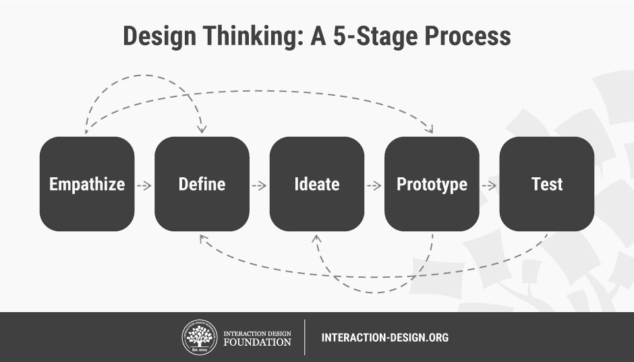

- Stage 1: Empathize—Research Your Users' Needs
The first stage of the design thinking process allows you to gain an empathetic understanding of the problem you’re trying to solve, typically through user research. Empathy is crucial to a human-centered design process like design thinking because it allows you to set aside your own assumptions about the world and gain real insight into users and their needs.
- Stage 2: Define—State Your Users' Needs and Problems
In the Define stage, you accumulate the information you created and gathered during the Empathize stage. You analyse your observations and synthesize them to define the core problems you and your team have identified so far. You should always seek to define the problem statement in a human-centred manner as you do this.
- Stage 3: Ideate—Challenge Assumptions and Create Ideas
Designers are ready to generate ideas as they reach the third stage of design thinking. The solid background of knowledge from the first two phases means you can start to “think outside the box”, look for alternative ways to view the problem and identify innovative solutions to the problem statement you’ve created.
- Stage 4: Prototype—Start to Create Solutions
This is an experimental phase, and the aim is to identify the best possible solution for each of the problems identified during the first three stages. Design teams will produce a number of inexpensive, scaled-down versions of the product (or specific features found within the product) to investigate the problem solutions generated in the previous stage.
- Stage 5: Test—Try Your Solutions Out
Designers or evaluators rigorously test the complete product using the best solutions identified in the Prototype phase. This is the final phase of the model but, in an iterative process such as design thinking, the results generated are often used to redefine one or more further problems. Designers can then choose to return to previous stages in the process to make further iterations, alterations and refinements to rule out alternative solutions.

The Origins of Design Thinking
Both the industrial revolution and World War II pushed the boundaries of what we thought was technologically possible. Engineers, architects and industrial designers—as well as cognitive scientists—then began to converge on the issues of collective problem solving, driven by the significant societal changes that took place at that time. Design thinking emerged, or should we say converged, out of the muddy waters of this chaos from the 50s and 60s onwards.
Cognitive scientist and Nobel Prize laureate Herbert A. Simon was the first to mention design thinking as a way of thinking in his 1969 book, The Sciences of the Artificial. He then went on to contribute many ideas throughout the 70s which are now regarded as principles of design thinking.
From the 1970s onwards, design thinking started to combine the human, technological and strategic needs of our times and progressively developed over the decades to become the leading innovation methodology it is today. Design thinking continues to gain ground across a wide range of industries and is still explored and enhanced by those at the forefront of the field.

Session 2: Agile SDLC
Introduction:
Agile SDLC model is a combination of iterative and incremental process models with focus on process adaptability and customer satisfaction by rapid delivery of working software product. Agile Methods break the product into small incremental builds. These builds are provided in iterations. Each iteration typically lasts from about one to three weeks. Every iteration involves cross functional teams working simultaneously on various areas like −
- Planning
- Requirements Analysis
- Design
- Coding
- Unit Testing and
- Acceptance Testing.
At the end of the iteration, a working product is displayed to the customer and important stakeholders.
Agile model believes that every project needs to be handled differently and the existing methods need to be tailored to best suit the project requirements. In Agile, the tasks are divided to time boxes (small time frames) to deliver specific features for a release.
Iterative approach is taken and working software build is delivered after each iteration. Each build is incremental in terms of features; the final build holds all the features required by the customer.
Here is a graphical illustration of the Agile Model −
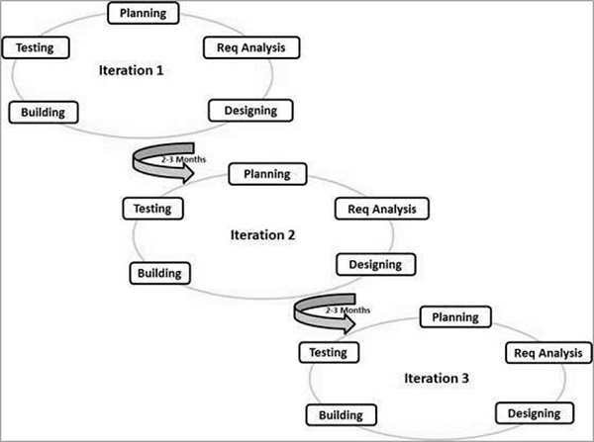

The Agile thought process had started early in the software development and started becoming popular with time due to its flexibility and adaptability.
The most popular Agile methods include Rational Unified Process (1994), Scrum (1995), Crystal Clear, Extreme Programming (1996), Adaptive Software Development, Feature Driven Development, and Dynamic Systems Development Method (DSDM) (1995). These are now collectively referred to as Agile Methodologies, after the Agile Manifesto was published in 2001.

Agile Manifesto principles –

- Individuals and interactions − In Agile development, self-organization and motivation are important, as are interactions like co-location and pair programming.
- Working software − Demo working software is considered the best means of communication with the customers to understand their requirements, instead of just depending on documentation.
- Customer collaboration − As the requirements cannot be gathered completely in the beginning of the project due to various factors, continuous customer interaction is very important to get proper product requirements.
- Responding to change − Agile Development is focused on quick responses to change and continuous development.

Agile Vs Traditional SDLC Models

Agile is based on the adaptive software development methods, whereas the traditional SDLC models like the waterfall model is based on a predictive approach. Predictive teams in the traditional SDLC models usually work with detailed planning and have a complete forecast of the exact tasks and features to be delivered in the next few months or during the product life cycle.
Predictive methods entirely depend on the requirement analysis and planning done in the beginning of cycle. Any changes to be incorporated go through a strict change control management and prioritization.
Agile uses an adaptive approach where there is no detailed planning and there is clarity on future tasks only in respect of what features need to be developed. There is feature driven development and the team adapts to the changing product requirements dynamically. The product is tested very frequently, through the release iterations, minimizing the risk of any major failures in future.
Customer Interaction is the backbone of this Agile methodology, and open communication with minimum documentation are the typical features of Agile development environment. The agile teams work in close collaboration with each other and are most often located in the same geographical location.

Agile Model - Pros and Cons
Agile methods are being widely accepted in the software world recently. However, this method may not always be suitable for all products. Here are some pros and cons of the Agile model.
The advantages of the Agile Model are as follows −
- Is a very realistic approach to software development.
- Promotes teamwork and cross training.
- Functionality can be developed rapidly and demonstrated.
- Resource requirements are minimum.
- Suitable for fixed or changing requirements
- Delivers early partial working solutions.
- Good model for environments that change steadily.
- Minimal rules, documentation easily employed.
- Enables concurrent development and delivery within an overall planned context.
- Little or no planning required.
- Easy to manage.
- Gives flexibility to developers.
The disadvantages of the Agile Model are as follows −
- Not suitable for handling complex dependencies.
- More risk of sustainability, maintainability and extensibility.
- An overall plan, an agile leader and agile PM practice is a must without which it will not work.
- Strict delivery management dictates the scope, functionality to be delivered, and adjustments to meet the deadlines.
- Depends heavily on customer interaction, so if customer is not clear, team can be driven in the wrong direction.
- There is a very high individual dependency, since there is minimum documentation generated.
- Transfer of technology to new team members may be quite challenging due to lack of documentation.

Session 3: DevOps

Introduction
DevOps is the combination of cultural philosophies, practices, and tools that increases an organization’s ability to deliver applications and services at high velocity: evolving and improving products at a faster pace than organizations using traditional software development and infrastructure management processes. This speed enables organizations to better serve their customers and compete more effectively in the market.
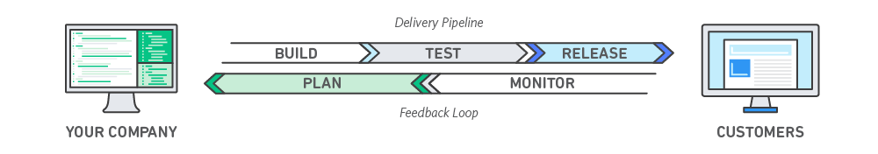
How DevOps Works?
Under a DevOps model, development and operations teams are no longer “siloed.” Sometimes, these two teams are merged into a single team where the engineers work across the entire application lifecycle, from development and test to deployment to operations, and develop a range of skills not limited to a single function.
In some DevOps models, quality assurance and security teams may also become more tightly integrated with development and operations and throughout the application lifecycle. When security is the focus of everyone on a DevOps team, this is sometimes referred to as DevSecOps.
These teams use practices to automate processes that historically have been manual and slow. They use a technology stack and tooling which help them operate and evolve applications quickly and reliably. These tools also help engineers independently accomplish tasks (for example, deploying code or provisioning infrastructure) that normally would have required help from other teams, and this further increases a team’s velocity.


Speed
Move at high velocity so you can innovate for customers faster, adapt to changing markets better, and grow more efficient at driving business results. The DevOps model enables your developers and operations teams to achieve these results. For example, microservices and continuous delivery let teams take ownership of services and then release updates to them quicker.
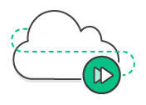

Rapid Delivery
Increase the frequency and pace of releases so you can innovate and improve your product faster. The quicker you can release new features and fix bugs, the faster you can respond to your customers’ needs and build competitive advantage. Continuous integration and continuous delivery are practices that automate the software release process, from build to deploy.
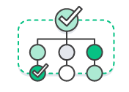

Reliability
Ensure the quality of application updates and infrastructure changes so you can reliably deliver at a more rapid pace while maintaining a positive experience for end users. Use practices like continuous integration and continuous delivery to test that each change is functional and safe. Monitoring and logging practices help you stay informed of performance in real-time.

Scale
Operate and manage your infrastructure and development processes at scale. Automation and consistency help you manage complex or changing systems efficiently and with reduced risk. For example, infrastructure as code helps you manage your development, testing, and production environments in a repeatable and more efficient manner.
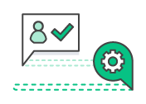

Improved Collaboration
Build more effective teams under a DevOps cultural model, which emphasizes values such as ownership and accountability. Developers and operations teams collaborate closely, share many responsibilities, and combine their workflows. This reduces inefficiencies and saves time (e.g. reduced handover periods between developers and operations, writing code that takes into account the environment in which it is run).


Security
Move quickly while retaining control and preserving compliance. You can adopt a DevOps model without sacrificing security by using automated compliance policies, fine-grained controls, and configuration management techniques. For example, using infrastructure as code and policy as code, you can define and then track compliance at scale.

Why DevOps Matters?
Software and the Internet have transformed the world and its industries, from shopping to entertainment to banking. Software no longer merely supports a business; rather it becomes an integral component of every part of a business. Companies interact with their customers through software delivered as online services or applications and on all sorts of devices. They also use software to increase operational efficiencies by transforming every part of the value chain, such as logistics, communications, and operations. In a similar way that physical goods companies transformed how they design, build, and deliver products using industrial automation throughout the 20th century, companies in today’s world must transform how they build and deliver software.

How to Adopt a DevOps Model?

1.DevOps Cultural Philosophy
Transitioning to DevOps requires a change in culture and mindset. At its simplest, DevOps is about removing the barriers between two traditionally siloed teams, development and operations. In some organizations, there may not even be separate development and operations teams; engineers may do both. With DevOps, the two teams work together to optimize both the productivity of developers and the reliability of operations. They strive to communicate frequently, increase efficiencies, and improve the quality of services they provide to customers. They take full ownership for their services, often beyond where their stated roles or titles have traditionally been scoped by thinking about the end customer’s needs and how they can contribute to solving those needs. Quality assurance and security teams may also become tightly integrated with these teams. Organizations using a DevOps model, regardless of their organizational structure, have teams that view the entire development and infrastructure lifecycle as part of their responsibilities.

2.DevOps Practices
There are a few key practices that help organizations innovate faster through automating and streamlining the software development and infrastructure management processes. Most of these practices are accomplished with proper tooling.
One fundamental practice is to perform very frequent but small updates. This is how organizations innovate faster for their customers. These updates are usually more incremental in nature than the occasional updates performed under traditional release practices. Frequent but small updates make each deployment less risky. They help teams address bugs faster because teams can identify the last deployment that caused the error. Although the cadence and size of updates will vary, organizations using a DevOps model deploy updates much more often than organizations using traditional software development practices.
Organizations might also use a microservices architecture to make their applications more flexible and enable quicker innovation. The microservices architecture decouples large, complex systems into simple, independent projects. Applications are broken into many individual components (services) with each service scoped to a single purpose or function and operated independently of its peer services and the application as a whole. This architecture reduces the coordination overhead of updating applications, and when each service is paired with small, agile teams who take ownership of each service, organizations can move more quickly.
However, the combination of microservices and increased release frequency leads to significantly more deployments which can present operational challenges. Thus, DevOps practices like continuous integration and continuous delivery solve these issues and let organizations deliver rapidly in a safe and reliable manner. Infrastructure automation practices, like infrastructure as code and configuration management, help to keep computing resources elastic and responsive to frequent changes. In addition, the use of monitoring and logging helps engineers track the performance of applications and infrastructure so they can react quickly to problems.
Together, these practices help organizations deliver faster, more reliable updates to their customers. Here is an overview of important DevOps practices.
The following are DevOps best practices:
- Continuous Integration
- Continuous Delivery
- Microservices
- Infrastructure as Code
- Monitoring and Logging
- Communication and Collaboration

Project Assigned: Teacher Student Connect

Overview:
The effectiveness of learning through academic institutions greatly depend on the theoretical coverage offered by the facilitators, above and beyond the details provided in the reference materials prescribed in the curriculum. To quote the success of the institution greatly depends on the additional enablement opportunities that are presented to those consuming the education offered in these house of knowledge.
The predominant objective is to enable the knowledge consumers with their day to day enablement needs and provide an online Repository that contains a collection of learning and teaching materials flowing from Teachers and Students on a regular basis.
An Interactive UI platform that allows the Teachers and Students to digitally connect that are aligned with the curriculum prescribed which would result in a 'deep driven' knowledge being gained by the learners or knowledge seekers.

Tools Used
Front End: Java (HTML, CSS3, JavaScript)
Html: It was developed by Tim Berners-Lee in 1990, HTML is short for Hypertext Markup Language. HTML is used to create electronic documents (called pages) that are displayed on the World Wide Web. Each page contains a series of connections to other pages called hyperlinks. Every web page you see on the Internet is written using one version of HTML code or another.
HTML code ensures the proper formatting of text and images so that your Internet browser may display them as they are intended to look. Without HTML, a browser would not know how to display text as elements or load images or other elements. HTML also provides a basic structure of the page, upon which Cascading Style Sheets are overlaid to change its appearance. One could think of HTML as the bones (structure) of a web page.

Css: Stands for "Cascading Style Sheet." Cascading style sheets are used to format the layout of Web pages. They can be used to define text styles, table sizes, and other aspects of Web pages that previously could only be defined in a page's HTML.
CSS helps Web developers create a uniform look across several pages of a Web site. Instead of defining the style of each table and each block of text within a page's HTML, commonly used styles need to be defined only once in a CSS document. Once the style is defined in cascading style sheet, it can be used by any page that references the CSS file. Plus, CSS makes it easy to change styles across several pages at once.

JavaScript: JavaScript is a programming language that started off simply as a mechanism to add logic and interactivity to an otherwise static Netscape browser. In the years since its introduction, it has not only supplanted a variety of other competing languages and technologies to become the standard for browser-based programming, but it has also expanded beyond the client space to become a dominant language on the server side, as well.

Middle ware: Java(MVC)
Model–View–Controller (usually known as MVC or Model WC for the MVVC variant) is an architectural pattern commonly used for developing user interfaces that divides an application into three interconnected parts. This is done to separate internal representations of information from the ways information is presented to and accepted from the user. The MVC design pattern decouples these major components allowing for efficient code reuse and parallel development.
Traditionally used for desktop graphical user interfaces (GUIs), this architecture has become popular for designing web applications. Popular programming languages like Java, C#, Python, Ruby, PHP have MVC frameworks that are used in web application development straight out of the box.

Backend: MySQL Server
MySQL is a open source Relational Database Management System (RDBMS) that uses Structured Query Language (SQL). SQL is the most popular language for adding, accessing and managing content in a database. It is most noted for its quick processing, proven reliability, ease and flexibility of use.
Software used: Visual Studio, Eclipse IDE for Java EE Developers (Oxygen), Tomcat v8.5, MySQL Community server 8.0, MySQL Workbench 8.0.14

Project Explanation
Page:1
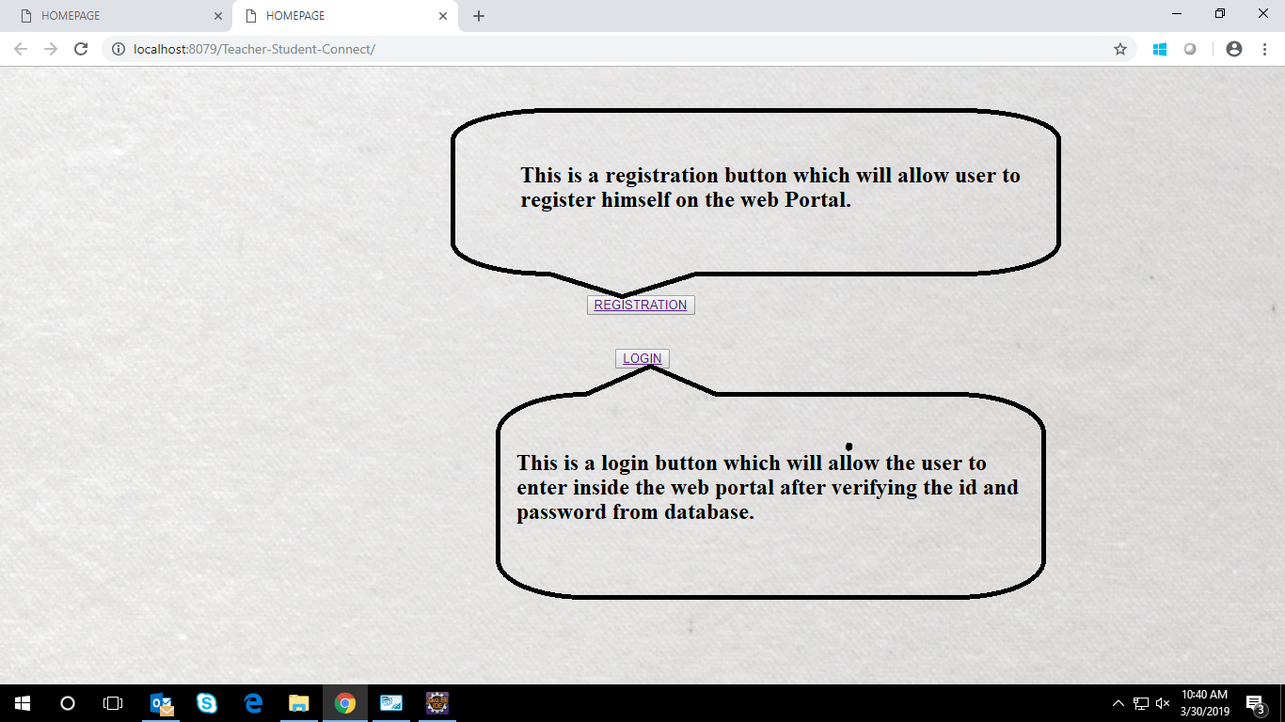
This is our first page. When any user will come to our web page he/she will be availed with
Registration and login option as shown above.

